Summary Statistics for Sales

1.Mean Sales: $1089.52

2.Median Sales: $1148.73

3.Standard Deviation of Sales: $558.23

Next, let's generate the visualizations for the data distributions and relationships.

Plotting the data:

1.Distribution of Sales Amounts

2.Relationship between Sales and Profit

3.Total Sales by Region

let's create these plots.

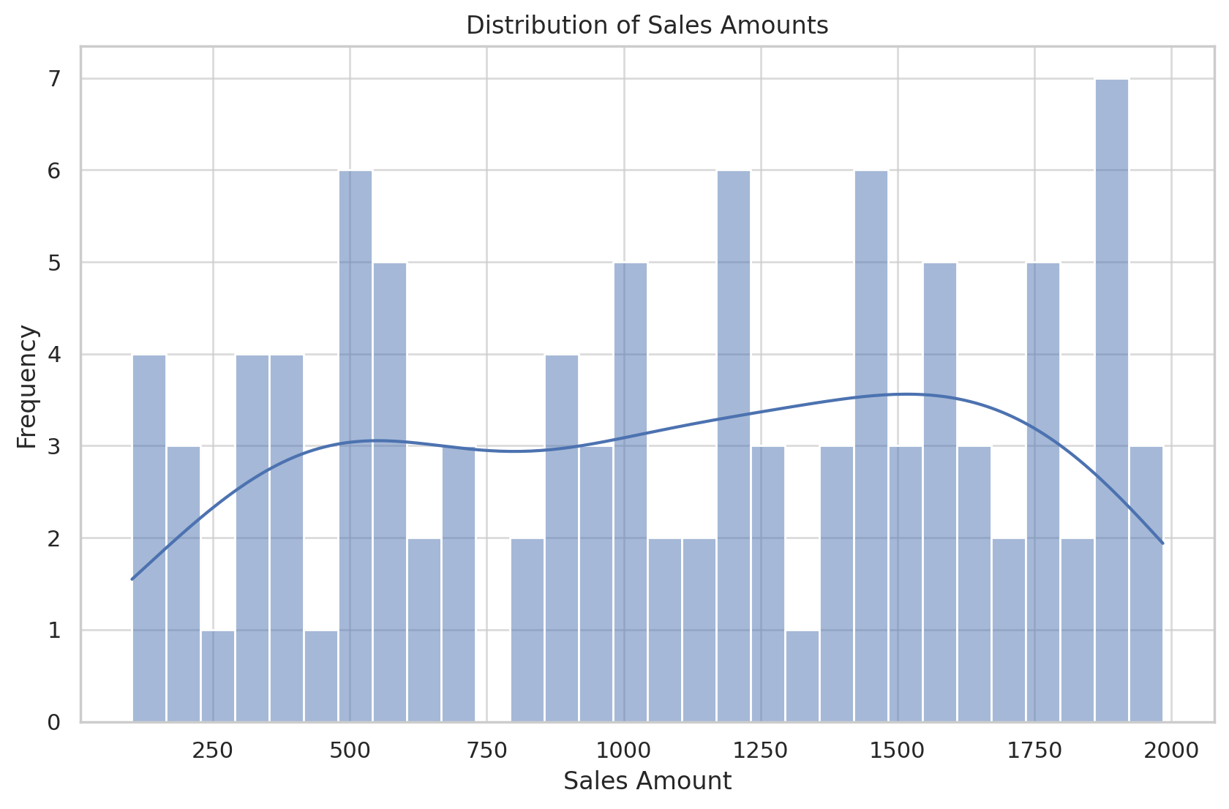

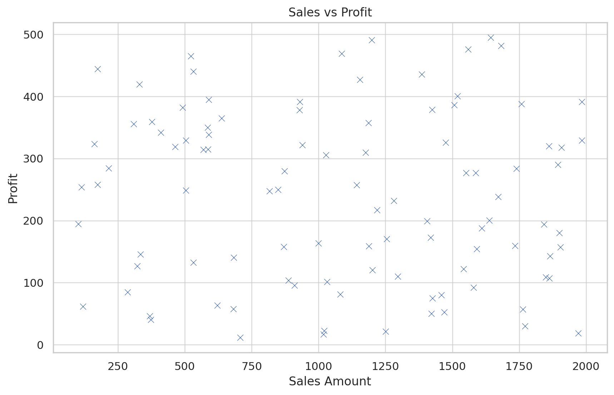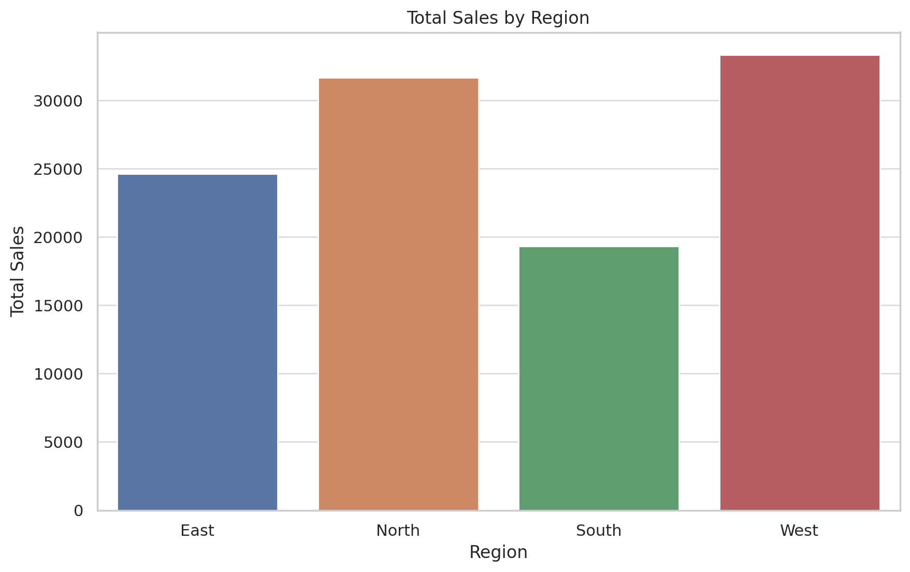

The visualizations are created successfully:

1. **Distribution of Sales Amounts**: The histogram shows the distribution of sales amounts, with a KDE (Kernel Density Estimate) line overlay to visualize the probability density function.
2. **Sales vs. Profit**: The scatter plot shows the relationship between sales and profit, indicating any correlation or pattern between these two variables.
3. **Total Sales by Region**: The bar plot shows the total sales amount for each region, highlighting which regions have higher or lower total sales.